# 4 Software architecture

## 4.1 Architecture requirements

### 4.1.1 Architectural scope

-The database will run on Afrihost

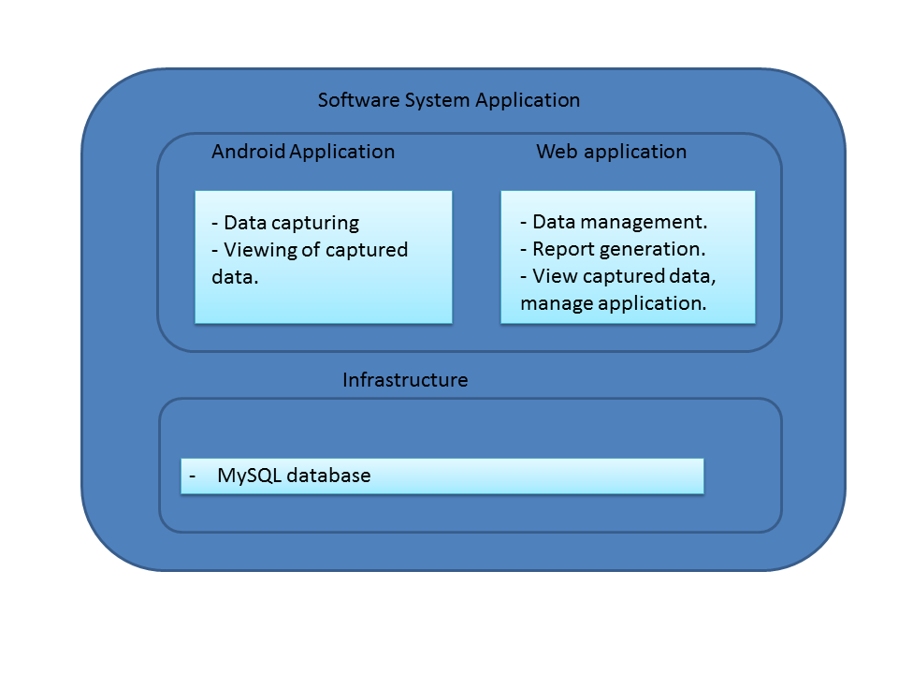

**Android app**

- The android application will be used to capture information on death scenes.

- View information based on clearance.

**Web app**

- will be used for data management.

-Report generation.

-System administration.

**Infrastructure**

* Data storage, MySQL database on Afrihost.

### 4.1.2 Quality requirements

Security

* Only authorised people should be able to have access to the system.
* Only administrator should register people.

Auditability

* Any change made to data stored should be recorded.
* Record what, who and when changes were made.

Performance

* Data should be sent in real time e.g. from forensic officer to forensic practitioner should receive it within 10 seconds.

Reliability

* The server should run all the time (24/7 - 365) and the connection should always be active.

Usability

* All the users should be able to use the system without any prior training.

### 4.1.3 Integration and Access channel

Access Channel

* Accessible by humans through the following channels
  + Admin – the access it through web application.
  + FO, FP and students – they show access the system through mobile application.

Integration Channel

* The new SQL database will be created in Afrihost.

### 4.1.4 Architectural constraints

- The system will use the following constraints

* Android SDK
* REST web services
* The system will be deployed in Asus Nexus 7 OS Android 4.1 jelly bean.

Technologies to be used

* Java, PHP, HTML, JavaScript, MySQL, JQuery, CSS ……..

## 4.2 Architectural Pattern

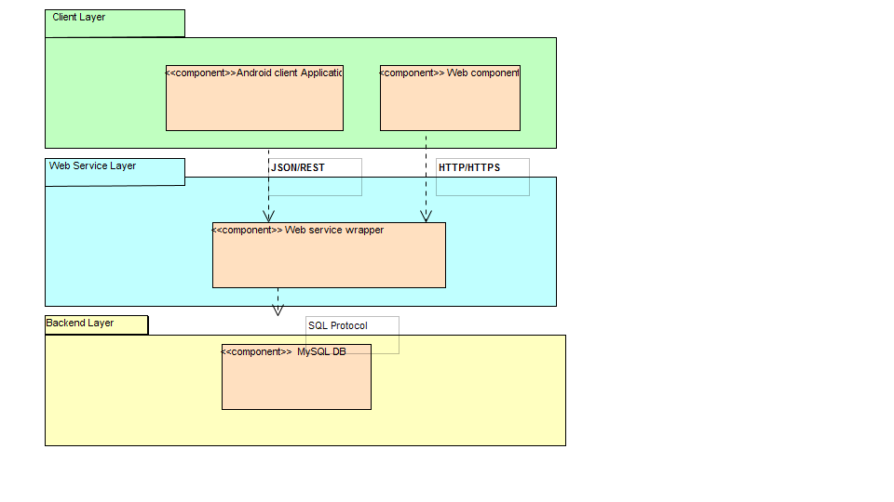

The Architectural pattern

1. Provides access to humans -> Client
2. Provides Functionality and objects required to client layer -> Web service
3. Host database -> Backend layer

The communication protocol are also shown. They include

1. HTTP/HTTPS from the browser to the web module.
2. JSON/REST/HTTP/HTTPS for the web services between the Android application and the database.